Who is Jesus: The Way? (John 14:1-7)
Jesus said: “I am the way, the truth, the life.” (John 14:6a)
What a beautiful and inviting verse of scripture.
It beckons us into a journey with Jesus.
It invites us on a path of truth and liberation.
How wonderfully freeing that is ….. until we are hit with the clobber clause:
“No one comes to the Father, except through me.” (v6b)
Hang on a second! Hang on!
If you are anything like me, this part of the verse hits you with a kind of elitist exclusivity. It seems to shout: ‘Jesus is the only way, and those that don’t choose Jesus will all be doomed.’
Sadly, that was certainly what I was taught growing up.
In the evangelical Anglican church of my childhood, it actually gave me a kind of comfort to think that I was part of that elite group.
I knew Jesus was the Way, so I would be saved.

But, then, as I grew up, I worried about those who were Jewish, or Muslim, or those who lived in places of the world where Christianity was just not a practiced. Did this verse really mean that they were all going to hell?
I began to question the intent of this verse. I mean if Jesus came to preach about loving our neighbors, and about acceptance, then how did that message jive with this verse of condemnation?
And, since Jesus’ friends were Jewish, did he really intend to exclude his people from the gift of life? I began to have grave concerns about how this verse was quoted and interpreted by many Christians.
Diana Butler Bass says that in this one verse …
“the welcome that Jesus offers is pulled back, boundaries are put up, and suddenly the picture shifts as the call to dance, sing, journey and run through the fields of life, fade into a rather grim image of judgement and exclusion.” (pg 166 Freeing Jesus)

So how can we explain and understand the juxtaposition of these two verses – Jesus’ invitation to a Way, with a seemingly condemnation to those who don’t know Jesus.

Perhaps you have never thought too deeply about this verse.
Perhaps you are ok taking it a face value.
Or perhaps like me, it causes you to wonder what exactly does Jesus mean in these words?
To answer this question, we need to reflect on what it means when we say, ‘Jesus is the Way.’
Today as we explore Jesus the Way, I invite you to put aside any preconceived ideas of this scripture, and to be open to hearing a different interpretation.

Perhaps we need to begin by putting this scripture into context.
The disciples were all afraid that Jesus would be leaving them soon – he has told them so again and again. In John 13 he tells them:
“I am with you only a little longer …. Where I am going you cannot come.” (John 13:33).
And again, in this scripture today, he tells them that he will be
“going to prepare a place for them.”(14:3)
They are frightened about what they will do without him.
Jesus had been a connection to the Divine for them – and they are worried that they will lose that connection of joy and life if they lose Jesus.
But then Jesus reminds them that they know ‘the way’ to God, because of everything that Jesus has taught them and shown them.
The disciples have come to know God in a new way, because of the works of love Jesus has done. And they will continue to know and experience God as they continue to do the work of love after Jesus is gone.
He tells them that they just need to abide in God’s love – the love that he has preached and lived while he was with them.
‘The Way’ – is living in the Way of Love.

Think of it this way:
Dwelling in God, and knowing God is not a static place with fixed walls, that only certain people can enter – it is a way of life open to all, and excluding none.

New testament scholar, Craig Koester wrote this about today’s scripture:
“’No one comes to the Father’ is not the last word. When Jesus said ‘except’, it is like a window that lets light into a closed room. It fits what the Gospel says about Christ coming as light into a world of darkness and serving as the door …. Rather than restricting access to God, the word ‘except’ creates access to God.”

Let me suggest then that ‘except’ in this clobber clause, is not a threat of exclusion, but rather, an invitation of love.
There would be no ‘way’, except that God has shown us ‘the way’ of love.
We would have much to fear, except God has shown us ‘the way’ to live without fear.
We would live distanced and separated from God, except God reaches out to the world in love.
Without this way of love – we would be lost in this world.
And yes – sometimes we are still lost in fields of doubt!

Butler Bass writes:
“’I am the way, the truth and the life,’ Jesus assured them.
Except for my showing you the way of God, you’d get lost.”

Being lost is a concept that is often referenced when we talk about Jesus the Way, and about our faith journeys. It’s surprising how many of the old hymns have the phrase “I was lost, but now I am found.”
But I think that the danger of this thinking, is that it can sometimes imply that there is a straight path, one way, that leads directly to God in heaven.
It’s like a ‘one way’ road sign.
And once you are on that straight path, everything is fine.

Growing up, I used to think like that. I was taught to believe that Jesus offered a straight road – or as Diana Butler Bass says – ‘an interstate highway to heaven.’
But honestly, deep down we all know that faith and life just does not work like that.
There are always knocks, and bumps, turns and twist along the way.
I am more inclined now to agree with Bass when she writes:

Jesus the Way is full of switch backs, spirals, and unexpected turns; mystery, paradox, unknowing, unsaying. Whenever you think you are near the centre, the path suddenly veers in a different direction and you find yourself again at the edge of the way. No wonder Jesus says ‘follow me’ and ‘I am the Way’. If it were not for the guide that Jesus offers, you might never find the path, even if sometimes you are only following breadcrumbs he left behind.

I don’t think the journey of faith is a straight path.
From my experience it can sometimes be more of a maze or a labyrinth.
It’s a winding journey through life, full of times of challenge, and times of joy. I don’t know how many of you have ever had the experience of walking on a labyrinth? There is wonderful one cut into the grass at Five Oaks in Paris.
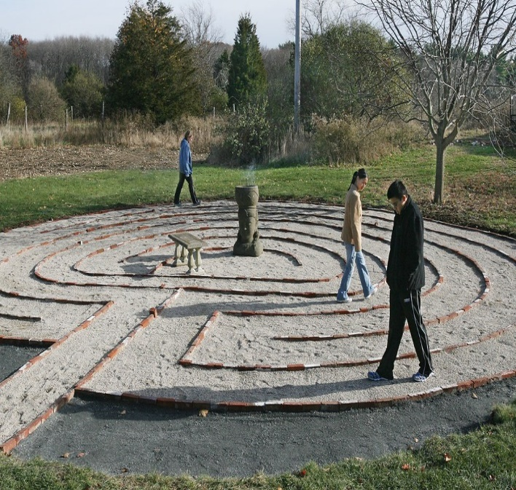
As you walk the winding paths, at times you seem close to the centre, then suddenly it takes you all the way around the outside again.
As the paths double back and travel alongside each other, you sometimes feel that you have been on the same path before – and yet somehow it feels different.
Just like the journey in life – perhaps there are times when we do find ourselves walking down the same path again, maybe a road that we don’t want to walk down, and we are needing again to learn what God is telling us.
But when you walk the labyrinth, the path is always taking you to the centre, and if you keep to the path, you will eventually make your way to the centre.

Walking a labyrinth is a good analogy for Jesus The Way – because Jesus doesn’t promise a straight path.
In fact, Jesus warns us that there will be times of challenge, times of sadness, times of injustice, and times when we just feel lost.

But the good news is that Jesus also promises us, that when we keep our focus on God’s love – the center of the labyrinth - then it can be a journey of truly experiencing and knowing God.
‘The Way’ that Jesus offers us, is a path where we open ourselves to finding and experiencing the love of God, and to reaching out to share that love with others.
It’s a journey of both inward reflection, and a journey that is outward action, where we are called to enact God’s love and justice in the world.
Where we are called To be Christ’s hands and feet, and to carry on the work that Jesus began.

Just as Jesus told his disciples “You know the way” – we know the way too.

Butler Bass writes:
“This quest is a map-less journey…there is no single road…. But, when you dare to leave the map behind then Jesus emerges as the road itself and the Light that guides. …. On a map-less journey, there is no destination, only the enveloping presence of love.”

When we think of Jesus as the Way in this context, it is not about a safe pass to heaven.
Instead, it is more about experiencing what Jesus embodied;
continuing the work that Jesus started of tearing down boundaries;
and of finding God deeply in the world around us.
And sometimes walking in this way can be risky.

It can be risky because you might need to speak out in the face of injustice – which might mean that others feel uncomfortable with what you say.

As we enter into a month when we celebrate black History – we need to look at how we as a church have been guilty of systemic racism.
And if we say, “I don’t think we are racist”, then the chances are that we don’t realize our own white privilege.
Yes, we have come a long way, but we have so much further to come to correct our injustices towards people who are black, indigenous, or people of color.

It also might be risky because it requires you to perhaps rethink the traditional dogma that suggests there is only one path that leads to God. We are invited to question - If God invites all people into this relationship of love, how can it be an exclusive relationship just for Christians?
I am proud to part of the The United Church that works toward “whole world ecumenism’ and has entered into multi faith conversations with our brothers and siters who are Muslim, Hindu, and Jewish.

I am reminded of the words of theologian Marcus Borg who wrote in The Heart Of Christianity:
“There are many paths up the mountain leading to God. As a Christian I chose to follow the path that Jesus showed us … but the winding path crosses over and walks parallel to other paths that also lead up the mountain to God.”

Jesus came to show us path up the mountain.
It is not exclusive path. It is an inviting way of love for everyone.
When we think of ‘Jesus the Way’ it is an embodiment of the Way of Love.

I end with some words from our United Church Song of Faith, that I think sum up Jesus The Way:
In Jesus’ life, teaching, and self-offering,
God shows us the way and empowers us to live in love. Amen.

