Calming the Storm
When I was the Minister at Knox United in Ayr, I started a program called Youth Ayr Community Theatre, better known by the acronym, YOUth ACT. It focused on performing musicals to tell well known bible stories. It was a great outreach opportunity that combined faith and fun in a creative way. We did the story of Noah with the play ‘100% Chance of Rain’; we did Jonah and the whale with ‘Jonah Man Jazz’; and we were right in the middle of ‘Giant Slayer’ when Covid shut us down, but not before we could make our huge Goliath puppet–check it out:
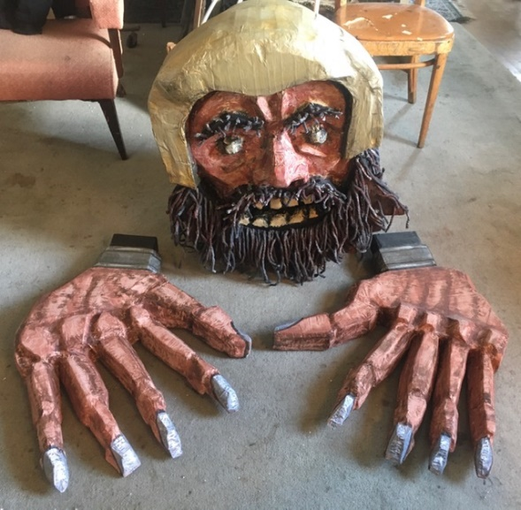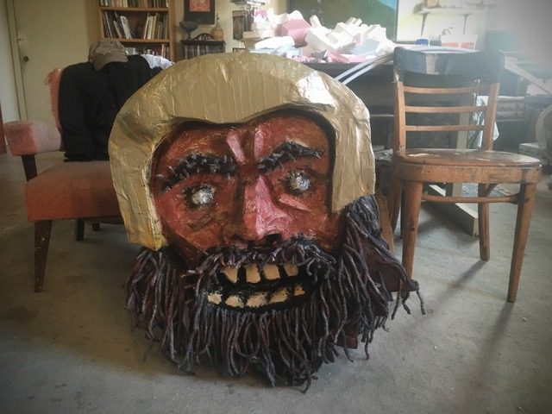

Well, I don’t know about you – but I think that is a pretty scary face – and those hands are huge! The description of Goliath in first Samuel is also pretty scary. In some translations it describes Goliath as ‘6 cubits and span’ which is 11’3”. That’s huge! The description of Goliath led to some really good great discussions in YOUth Act about things that scare us.
Our second reading today, about a storm on the water, is also pretty scary. It is described as a furious squall, with waves crashing over the boat, and the boat being filled with water to the point that it is almost sinking! I don’t have much experience in sailing, but some years ago I took my Skipper B license on lake Ontario, and I can tell you that when we heard about weather conditions like this, we would be heading for land as quickly as possible! No one wants to be out in a boat in a furious squall, and it was absolutely right for the disciples to be afraid of drowning.
So, it would be fair to say that a link in these two scripture stories from the lectionary today, is that they are both about facing our fears. How can we have courage – but that is what I preached on last week.

I think another link between these two scriptures, is how we must allow Divine power, a power that is beyond ourselves, to work through us to do amazing things.
Against all the odds, little David prevailed over the giant with just five little stones and a sling. He brothers mocked him and laughed at the very notion that he would face Goliath.
And, against all the odds, Jesus calmed a violent storm with the simple command “Quiet! Be Still!”
How can this be?
It makes no sense. It is beyond our intellect.
I am sure that most of us would have been like the troops of Israel. We would have been terrified, we would have lost all hope, and we would have given in.
Or we would be like the disciples, terrified of drowning, and given in.
But both these stories are not about giving in – they about giving way to God’s Divine power. A power that can overcome anything.
They are about giving way to allow God’s Spirit to move the immovable.

Theologian Diana Buttler Bass describes this ‘giving way to God’ as “moving with the Spirit.” She suggests that we are in a time of Spiritual Awakening. We are in a time when so much around us is changing, including the church.

Who would ever of thought that we would be worshipping via Zoom and You Tube. The Worship team at Grace met this week to talk about Parking lot Sundays in July, where we plan to gather outside, but sit in our own bubbles. It is true that Covid has made us think outside the box – but perhaps some of this is good.
Perhaps this is making us move with the Spirit.
I know we desperately miss our sanctuary, and the day will come when we can gather in it again. But that doesn’t mean that we will just go back to the way things were. Buttler Bass writes: “You may wish to mourn the loss of what was, but there is no need to fear what will be, for the future is here only in part….”

What does the future of the church look like?
What does the future of our community of faith look like?
Well, no-one has a crystal ball, but I can tell you that when a church is willing to be spiritually awakened, there is a shift in three main areas: Belonging, Behaving and Believing. The three ‘B’s.
And, even in my short time here at Grace, I have learned that you are people that are willing to be Spiritually Awakened.

In BELONGING there is a shift from membership, towards relationship with each other. We have seen that in the care and compassion of those reaching out with phone calls over the last year. With the caring porch visits, and the way we reach out to stay connected. It’s not about if you are member of Grace or not – it is about being in relationship with each other.
And it is important to remember that this ‘being in relationship’ extends beyond our community of faith – into the wider community, and into the global community too.
At the recent inter-faith vigil and march in London to support the Muslim community – you could see how compassionate relationships extend beyond membership to our church, beyond membership to our denomination, and even beyond our faith traditions. It was a reminder that we all BELONG to God, and we are called into relationship.
In BEHAVING there is a shift away from ‘keeping all the rules’, towards practicing our faith by living out our faith in action. The new Food For Friends program is a great example of this. It is a little daunting to start a new program, especially during Covid but it also reminds us how we are called to live out our faith in action. That can be risky sometimes. We have to be like David and remember to trust that God can use us. It can be really hard to do this – but when we are willing to give way to the Spirit, we can do amazing things – even overcome giants!
And in BELIEVING there is a shift away from the dogma of religion, towards exploring ways of experiencing the Spirit. We can do this through spiritual practices of prayer, meditation, scripture, silence, prayer walks and more. Our Inspirational messages have been exploring some of these practices, particularly with our recent Stroll For the Soul series. The responses that I have received by email and phone calls, tell me that many of you are enjoying perhaps new ways of exploring and experiencing the Spirit around you. As you continue to give way to the Spirit, your faith and belief in the mystery of the Divine will continue to grow.

Some people may say that we are in the midst of a church decline, and they worry about how will be ever get people back after Covid.
They might respond with fear and hopelessness, like the Israelites when faced with a giant, or like the disciples in the middle of a storm at sea.

But perhaps another way to look at it is that we are in the midst of a Spiritual Awakening.
There is no denying that awakenings are hard work, they take faith and trust - but they are the work of God.
Let us claim the promise in Psalm 37 that God has a grip on our hands and will not let us fall. It’s the promise that David held onto as he faced the giant.
Let us have the faith of David, or better still, the certainty of Jesus.
Remember, in the midst of the storm, Jesus calmly slept, and when awoken by the terrified disciples, he responded with the question:
“Do you have no faith?”

I know that last couple of weeks have been very hard for us. We are shocked, we mourn, we wonder what we can do. But when things might seem so overwhelming for you, perhaps we need to ask ourselves the same question.
Do you have no faith?
Or, are we willing to give way to the Spirit, and trust that God can and will overcome this giant that is in our midst?
Are we willing to trust that God can and will calm the storm that we are in?
Are we willing to allow God’s Spirit to move through us, fill us with hope, and empower us to stand up for a new tomorrow?

This last year has been hard for all of us. But I believe we are on a remarkable journey of Spiritual Awakening. We have come a long way, but we still have work to do. Let us not give in, but instead, let us give way to God working through us.
Amen.

